Code:
import java.io.*;
import javax.servlet.*;
import javax.servlet.http.*;

public class MiServlet extends HttpServlet {

public void doGet(HttpServletRequest request, HttpServletResponse response) throws ServletException, IOException {
response.setContentType("text/html");
PrintWriter impresor = response.getWriter();

// Retrieve parameters from the request
String num1 = request.getParameter("num1");
String num2 = request.getParameter("num2");
String operation = request.getParameter("operation");

double result = 0;
String errorMessage = null;

try {
if (num1 != null && num2 != null && operation != null) {
double number1 = Double.parseDouble(num1);
double number2 = Double.parseDouble(num2);

// Perform the selected operation
switch (operation) {
case "add":
result = number1 + number2;
break;
case "subtract":
result = number1 - number2;
break;
case "multiply":
result = number1 * number2;
break;
case "divide":
if (number2 == 0) {
errorMessage = "Error: Division by zero is not allowed.";
} else {
result = number1 / number2;
}
break;
default:
errorMessage = "Invalid operation.";
}
}
} catch (NumberFormatException e) {
errorMessage = "Error: Invalid input. Please enter valid numbers.";
}

// Generate HTML form and result display
impresor.println("<html>");
impresor.println("<head><title>Calculator</title></head>");
impresor.println("<body>");
impresor.println("<h1>Calculator</h1>");
impresor.println("<form method='get'>");
impresor.println("<label>Number 1: <input type='text' name='num1' value='" + (num1 != null ? num1 : "") + "'></label><br>");
impresor.println("<label>Number 2: <input type='text' name='num2' value='" + (num2 != null ? num2 : "") + "'></label><br>");
impresor.println("<label><input type='radio' name='operation' value='add' " + ("add".equals(operation) ? "checked" : "") + "> Add</label><br>");
impresor.println("<label><input type='radio' name='operation' value='subtract' " + ("subtract".equals(operation) ? "checked" : "") + "> Subtract</label><br>");
impresor.println("<label><input type='radio' name='operation' value='multiply' " + ("multiply".equals(operation) ? "checked" : "") + "> Multiply</label><br>");
impresor.println("<label><input type='radio' name='operation' value='divide' " + ("divide".equals(operation) ? "checked" : "") + "> Divide</label><br>");
impresor.println("<button type='submit'>Calculate</button>");
impresor.println("</form>");

// Display result or error message
if (errorMessage != null) {
impresor.println("<p style='color: red;'>" + errorMessage + "</p>");
} else if (num1 != null && num2 != null && operation != null) {
impresor.println("<p>Result: " + result + "</p>");
}

impresor.println("</body>");
impresor.println("</html>");
}
}

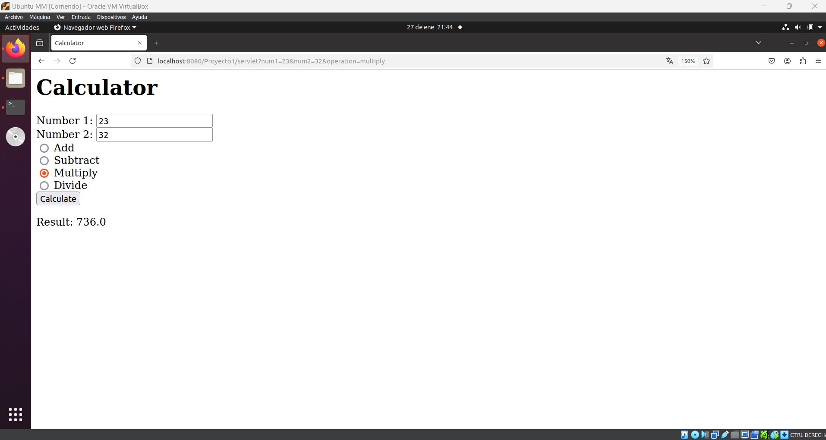
Example:

